Book Alley

Software Development Plan (Small Project)

Version 1.1

Revision History

| **Date** | **Version** | **Description** | **Author** |
| --- | --- | --- | --- |
| 28/10/2023 | 1.0 | Initial Release | Dang Ha Huy |
| 16/11/2023 | 1.1 | Revised Project plan | Dang Ha Huy |
|  |  |  |  |
|  |  |  |  |

Table of Contents

**- 4**

**1. Introduction 4**

*1.1 Purpose 4*

*1.2 Scope 4*

*1.3 Overview 4*

**2. Project Overview 4**

*2.1 Project Purpose, Scope, and Objectives 4*

*2.2 Assumptions and Constraints 4*

*2.3 Project Deliverables 4*

**3. Project Organization 5**

*3.1 Organizational Structure 5*

*3.2 Roles and Responsibilities 5*

**4. Management Process 6**

*4.1 Project Estimate 6*

*4.2 Project Plan 6*

4.2.1 Phase Plan 6

4.2.2 Iteration Objectives 6

4.2.3 Releases 7

4.2.4 Project Schedule 7

4.2.5 Project Resourcing 13

*4.3 Project Monitoring and Control 14*

4.3.1 Requirements Management 14

4.3.2 Reporting and Measurement 14

4.3.3 Risk Management 14

4.3.4 Configuration Management 15

Software Development Plan (Small Project)

# 

# Introduction

## Purpose

The purpose of this *Software Development Plan* is to plan out all of the necessary phases (or milestones) that are needed in order to implement an e-commerce web application with all the key features listed in the PA0. It also lists out some compulsory requirements that are needed to be followed in order to achieve a successful project.

The following people use the *Software Development Plan*:

* The **project manager** uses it to plan the project schedule and resource needs, and to track progress against the schedule.
* **Project team members** use it to understand what they need to do, when they need to do it, and what other activities they are dependent upon.

## Scope

This *Software Development Plan* describes the overall plan to be used by the Book Alley project, including deployment of the product. The details of the individual iterations will be described in the Iteration Plans.  
The plans as outlined in this document are based upon the product requirements as defined in the *Vision Document*.

## Overview

This *Software Development Plan* contains the following information:

Project Overview — provides a description of the project's purpose, scope, and objectives.

Project Organization — describes the organizational structure of the project team.

Management Process — Estimated the time to finish each milestone, the cost in each sprint and plan out which task should be done next week

# Project Overview

## Project Purpose, Scope, and Objectives

- The purpose of this project is to create an e-commerce website dedicated to selling books. The main objectives are to provide a user-friendly platform for customers to browse and purchase books, manage an extensive catalog efficiently and facilitate a seamless shopping experience. Additionally, the website should support user reviews and personalized content to enhance customer engagement. The project is expected to deliver a full-fleshed website e-commerce website with all the key features mention in PA0

## Assumptions and Constraints

*-* This project must be finished before the course “Introduction to Software Engineering” ends (12 weeks)

- Each milestone must be completed within a limited time frame in order to finish to website in time

## Project Deliverables

- A comprehensive catalog of books with relevant details and categorization.

- Fully functional e-commerce website with a user-friendly interface.

- Secure payment processing and checkout functionality.

- User review and rating system for book feedback.

- Personalization features for customized book recommendations.

- Documentation and training materials for future maintenance and updates.

# Project Organization

## Organizational Structure

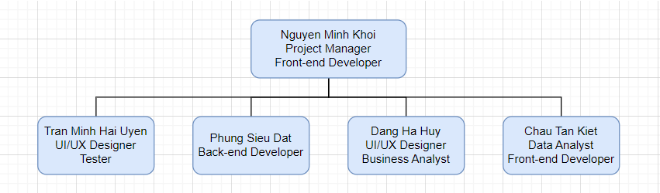

## Roles and Responsibilities

| **Person** | **Role** |
| --- | --- |
| Nguyen Minh Khoi  Project Manager, Front-end Developer | - Responsible for project planning, scheduling, and overall coordination.  - Focus on developing the front-end of the web application.  - Collaborate with UI/UX designers to create the visual design and layout of the web application.  - Work with UI/UX designers to ensure a user-friendly and intuitive user experience.  - Test the front-end components to identify and report bugs and issues. |
| Tran Minh Hai Uyen  UI/UX Designer, Tester | - Responsible for designing the user interface and ensuring a pleasant user experience  - Test the user interface to ensure it aligns with the design and report any usability issues  -Work with front-end developers to ensure the front-end and data analytics align with the design and user experience.  - Facilitate communication among team members and stakeholders. |
| Phung Sieu Dat  Back-end Developer | - Responsible for building the back-end infrastructure of the web application, including databases and server functionality.  - Manage the database system, ensuring data is organized and secure.  - Develop APIs for data communication between the front-end and back-end.  - Implement security measures to protect user data and the application.  - Optimize the back-end for speed and scalability. |
| Dang Ha Huy  UI/UX Designer, Business Analyst | - Also work with front-end developers to ensure the front-end and data analytics align with the design and user experience.  - Assist with project documentation, file management, reports and information retrieval.  - Create design documentation and guidelines for the project.  - Provide general administrative assistance to the team. |
| Chau Tan Kiet  Front-end Developer, Data Analyst | - Work with Nguyễn Minh Khôi on the front-end development of the web application.  - Analyze user data and behavior to provide insights for improving the application.  - Assist in integrating data analytics tools with the web application.  - Conduct research on user preferences and behaviors to guide development.  - Collaborate with Trần Minh Hải Uyên to ensure that data analytics features are properly integrated and tested. |

# Management Process

## Project Estimate

- Cost:

* No cost in money
* About 2 hours of work everyday 6 days a week
* 6 sprints (from 1 to 6 with 1 sprint every 2 weeks)

- Schedule: from 5/10/2023 to 27/12/2023

- We will re-estimate every time we hit a milestone

## Project Plan

### Phase Plan

-The development of the Book Alley will be conducted using a phased approach where multiple iterations occur within a phase. The phases and the relative timeline is shown in the table below:

| **Phase** | **No. of iteration** | **Start** | **End** |
| --- | --- | --- | --- |
| Inception phase | 1 | Week 1 | Week 3 |
| Elaboration phase | 1 | Week 3 | Week 8 |
| Construction phase | 2 | Week 4 | Week 11 |

### Iteration Objectives

| **Phase** | **Iteration** | **Description** | **Objective** |
| --- | --- | --- | --- |
| Inception phase | Preliminary Iteration (including PA0) | Define business model, project plan, software development plan and all the requirements for the project | Objective: Business Case Review  Output: PA0 |
| Elaboration phase | Development architectural prototype | - Completes analysis & design for all Book Alley use cases.  - Develops the architectural prototype for TechWorld.  - Complete analysis & design for all high risk TechWorld use cases. | Objective: Architectural prototype  Output: PA1 to PA4 |
| Construction phase | Develope Book Alley Official release | - Implement Book Alley version 1.0  - Fix defects and bugs from Book Alley 1.0  - Release the final version of Book Alley | Objective: Book Alley website release  Output: PA5, presentation about Book Alley final version |

### Releases

Version 1.0 is expected to have these basic functions:

- A functional homepage

- Authentication

- Search and Filtering

- Rating and Reviews

- Product wishlist

- Secure payment methods

- Accounts management

- Products management

- Order tracking

Version 2.0:

- Two-factor authentication

- Login via third party (Google, Facebook,etc)

- Recommendation systems

- Payment via third party (E-Banking, Momo, Paypal, etc)

- Analytic

### Project Schedule

Note that this project schedule is just an estimation and is subjected to change in the future

| **Task** | **Duration** | **Start** | **End** | **Responsibility** |
| --- | --- | --- | --- | --- |
| Sprint 1 | 14 days | 5/10/2023 | 17/10/2023 | All members |
| Setup Group chat, Github, Figma, Jira to manage the project | 3 days | 5/10/2023 | 7/10/2023 | Tran Minh Hai Uyen  Nguyen Minh Khoi |
| Suggesting idea for the project | 4 days | 7/10/2023 | 11/10/2023 | All member |
| Start setting up the basic function of the project | 3 days | 11/10/2023 | 14/10/2023 | Phung Sieu Dat  Chau Tan Kiet |
| Finish writing PA0 | 3 days | 14/10/2023 | 17/10/2023 | All members |
| Sprint 2 | 14 days | 18/10/2023 | 31/10/2023 | All members |
| Project Plan | 7 days | 18/10/2023 | 25/10/2023 | Dang Ha Huy  Phung Sieu Dat |
| Vision Document | 7 days | 18/10/2023 | 25/10/2023 | Chau Tan Kiet  Nguyen Minh Khoi |
| Finish Weekly report 1 | 2 days | 23/10/2023 | 25/10/2023 | Tran Minh Hai Uyen |
| Design concept for website Homepage | 7 days | 18/10/2023 | 25/10/2023 | Tran Minh Hai Uyen  Dang Ha Huy |
| Design database structure | 3 days | 18/10/2023 | 20/10/2023 | Dang Ha Huy  Chau Tan Kiet |
| Setup backend environment | 3 days | 18/10/2023 | 20/10/2023 | Phung Sieu Dat |
| Implement database | 5 days | 20/10/2023 | 24/10/2023 | Phung Sieu Dat |
| Implement design of Homepage | 5 days | 26/10/2023 | 30/10/2023 | Nguyen Minh Khoi |
| Finish Weekly report 2 | 2 days | 29/10/2023 | 31/10/2023 | Tran Minh Hai Uyen |
| Test & Revision | 1 day | 31/10/2023 | 31/10/2023 | Tran Minh Hai Uyen |
| Finish writing PA1 | 5 days | 26/10/2023 | 31/10/2023 | All |
| Sprint 3 | 14 days | 1/11/2023 | 14/11/2023 | All members |
| Designing the logic of homepage | 7 days | 1/11/2023 | 7/11/2023 | Nguyen Minh Khoi  Chau Tan Kiet |
| Fix the errors | 1 day | 1/11/2023 | 1/11/2023 | Nguyen Minh Khoi  Phung Sieu Dat |
| Finish use-case specification | 7 days | 1/11/2023 | 7/11/2023 | Dang Ha Huy |
| Finish software architecture | 7 days | 1/11/2023 | 8/11/2023 | Nguyen Minh Khoi |
| Draw use-case diagram | 3 days | 1/11/2023 | 3/11/2023 | Tran Minh Hai Uyen |
| Design Login/Register Page | 5 days | 1/11/2023 | 6/11/2023 | Tran Minh Hai Uyen |
| Design Product Detail Page | 5 days | 10/11/2023 | 14/11/2023 | Dang Ha Huy |
| Implement user authentication | 5 days | 1/11/2023 | 5/11/2023 | Phung Sieu Dat |
| Implement basic CRUD API for product | 7 days | 6/11/2023 | 12/11/2023 | Phung Sieu Dat |
| Implement Login/Register page | 3 days | 8/11/2023 | 10/11/2023 | Nguyen Minh Khoi |
| Implement Product Detail page | 4 days | 11/11/2023 | 14/11/2023 | Chau Tan Kiet |
| Test & Revision | 1 day | 14/11/2023 | 14/11/2023 | Tran Minh Hai Uyen |
| Finish writing PA2 | 5 days | 10/11/2023 | 14/11/2023 | All members |
| Sprint 4 | 14 days | 15/11/2023 | 28/11/2023 | All members |
| Design seller dashboard | 5 days | 15/11/2023 | 19/11/2023 | Dang Ha Huy  Tran Minh Hai Uyen |
| Fix the errors | 1 day | 15/11/2023 | 15/11/2023 | Nguyen Minh Khoi  Phung Sieu Dat |
| Find data about books to and design | 4 days | 15/11/2023 | 18/11/2023 | Chau Tan Kiet |
| Cleaning dataset gained and push to database | 2 days | 18/11/2023 | 19/11/2023 | Chau Tan Kiet |
| Finish weekly report 1 | 2 days | 20/11/2023 | 21/11/2023 | Tran Minh Hai Uyen |
| Implement review products | 5 days | 18/11/2023 | 22/11/2023 | Nguyen Minh Khoi |
| Implement seller dashboard | 5 days | 23/11/2023 | 27/11/2023 | Nguyen Minh Khoi |
| Implement API for reviews | 3 days | 15/11/2023 | 17/11/2023 | Phung Sieu Dat |
| Implement API for sellers | 7 days | 18/11/2023 | 18/11/2023 | Phung Sieu Dat |
| Setup production environment and test deployment | 3 days | 24/11/2023 | 26/11/2023 | Phung Sieu Dat |
| Finish writing PA3 | 5 days | 24/11/2023 | 28/11/2023 | Dang Ha Huy |
| Test & Revision | 1 day | 28/11/2023 | 28/11/2023 | Tran Minh Hai Uyen |
| Finish weekly report 2 | 2 days | 27/11/2023 | 28/11/2023 | Tran Minh Hai Uyen |
| Sprint 5 | 14 days | 29/11/2023 | 12/12/2023 | All members |
| Design cart and payment page | 5 days | 29/11/2023 | 3/12/2023 | Dang Ha Huy  Tran Minh Hai Uyen |
| Fix the errors | 1 day | 29/11/2023 | 29/11/2023 | Nguyen Minh Khoi  Phung Sieu Dat |
| Design the minor features (About us, contacts) | 4 days | 29/11/2023 | 2/12/2023 | Chau Tan Kiet |
| Implement cart and payment page | 4 days | 4/12/2023 | 7/12/2023 | Nguyen Minh Khoi |
| Implement the minor features (About us, contacts) | 5 days | 8/12/2023 | 12/12/2023 | Nguyen Minh Khoi  Chau Tan Kiet |
| Finish weekly report 1 | 2 days | 8/12/2023 | 10/12/2023 | Tran Minh Hai Uyen |
| Test the web application | 2 days | 7/12/2023 | 8/12/2023 | Tran Minh Hai Uyen |
| Evaluating the testing results | 2 days | 8/12/2023 | 9/12/2023 | Chau Tan Kiet |
| Implement backend for shopping cart and orders, payment | 10 days | 29/11/2023 | 7/12/2023 | Phung Sieu Dat |
| Finish writing PA4 | 5 days | 8/12/2023 | 12/12/2023 | Dang Ha Huy |
| Finish weekly report 2 | 2 days | 11/12/2023 | 12/12/2023 | Nguyen Minh Khoi |
| Sprint 6 | 14 days | 13/12/2023 | 27/12/2023 | All members |
| Refactor codebase | 3 days | 13/12/2023 | 15/12/2023 | Nguyen Minh Khoi  Phung Sieu Dat |
| Write test cases | 5 days | 15/12/2023 | 19/12/2023 | Nguyen Minh Khoi  Phung Sieu Dat |
| Testing the website as a whole | 3 days | 19/12/2023 | 22/12/2023 | Tran Minh Hai Uyen |
| Analyzing and getting insights from test results | 2 days | 23/12/2023 | 24/12/2023 | Chau Tan Kiet |
| Releasing the product | 1 day | 24/12/2023 | 25/12/2023 | Phung Sieu Dat |
| Preparing slides for presentation | 7 days | 20/12/2023 | 26/12/2023 | All members |
| Finish PA5 | 5 days | 22/12/2023 | 26/12/2023 | Dang Ha Huy |

Gantt chart:

* Overview:  
  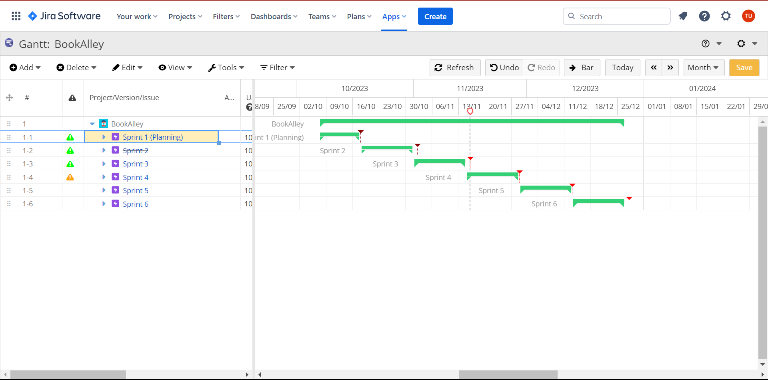
* Sprint 1:

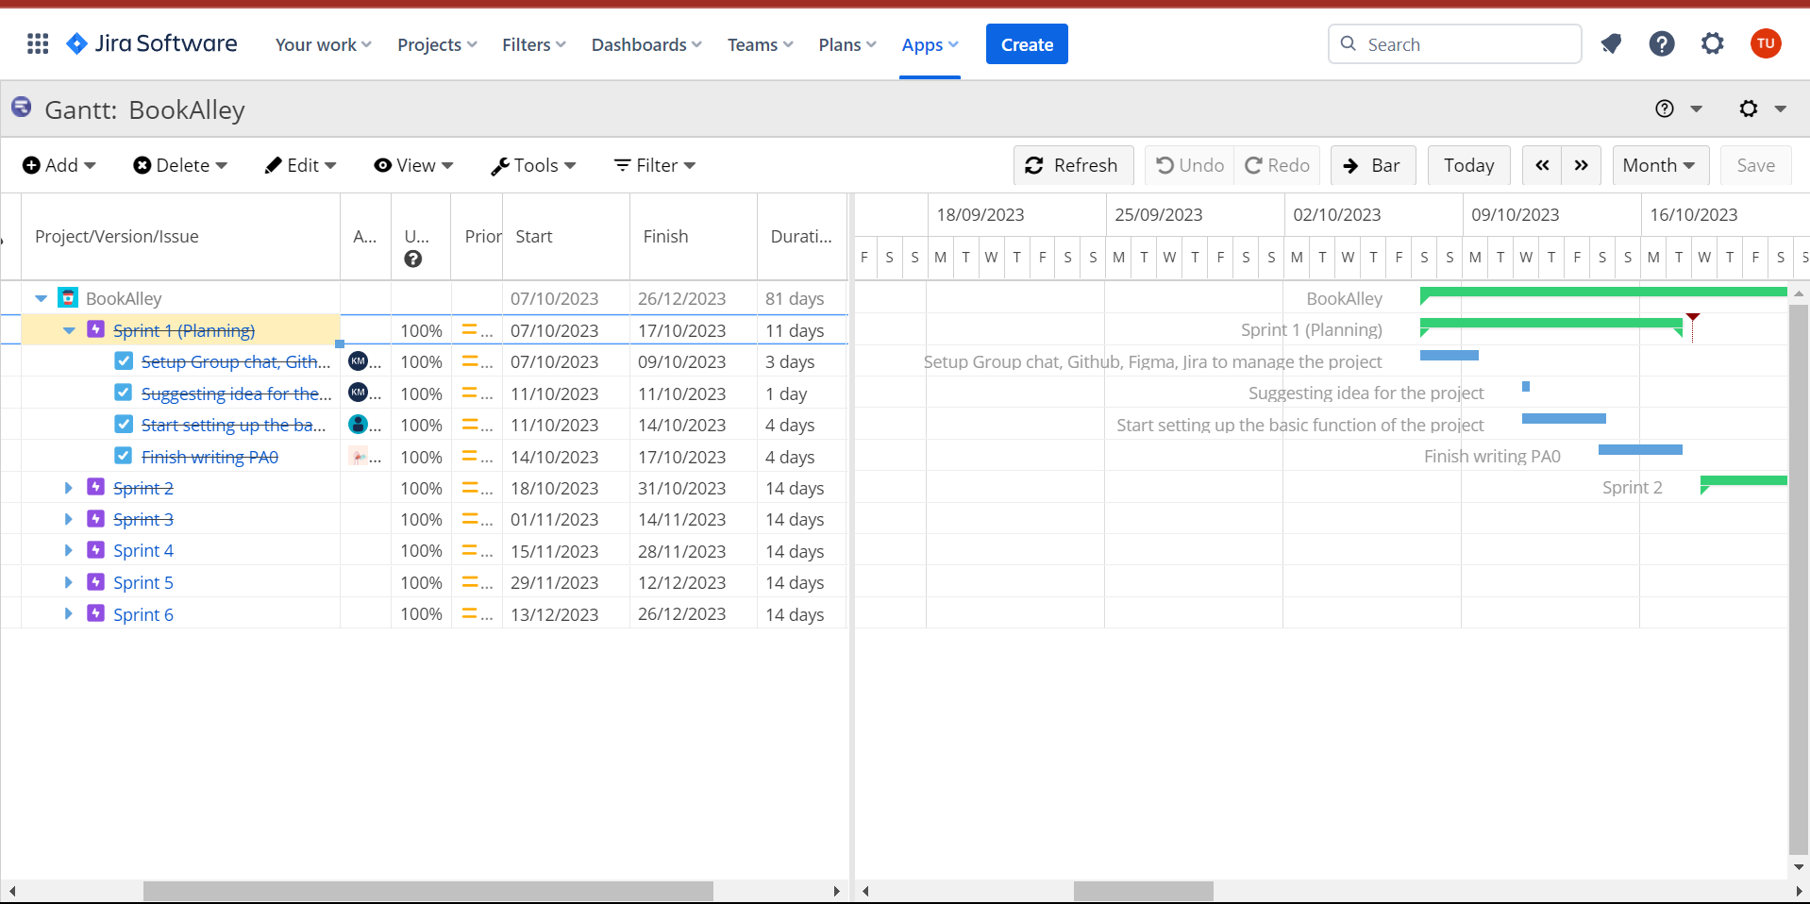

* Sprint 2:

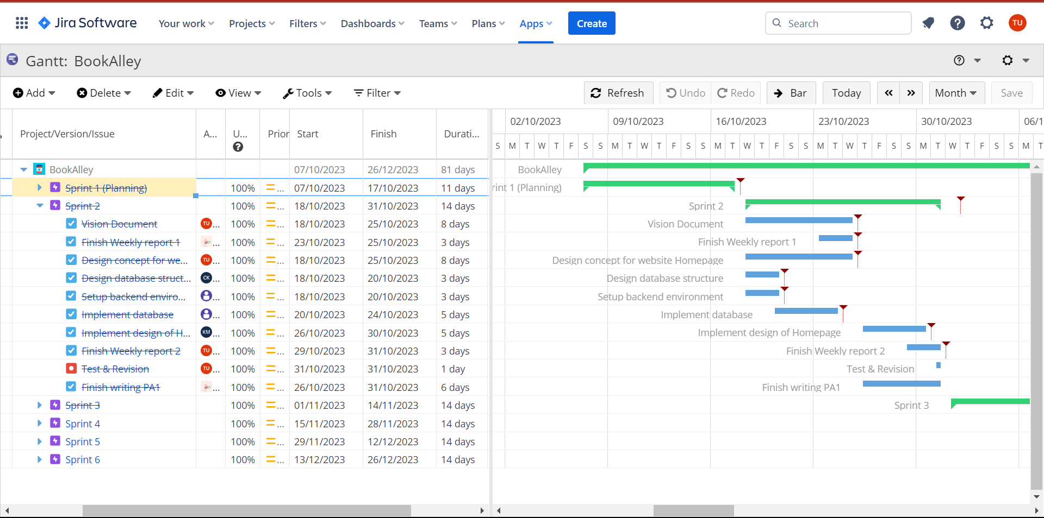

* Sprint 3:

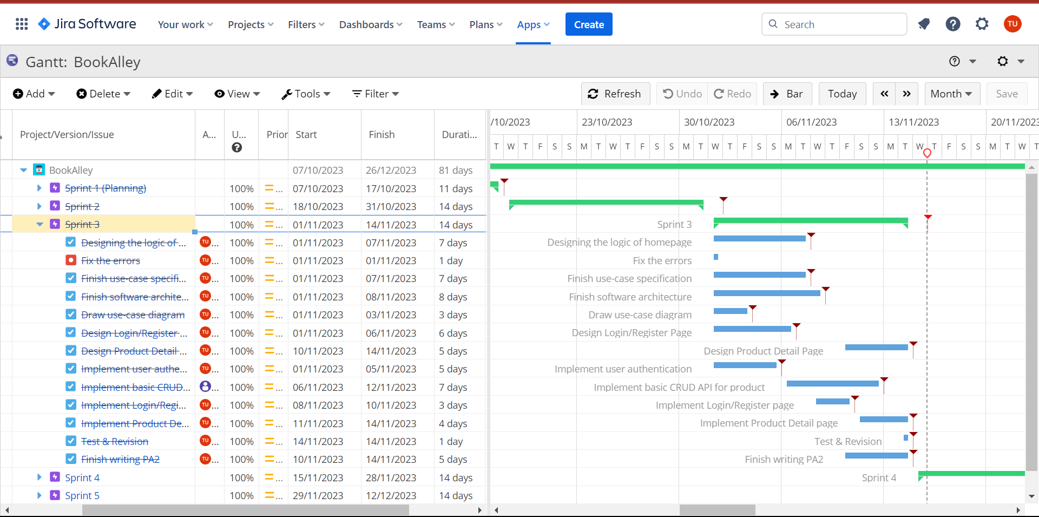

* Sprint 4:

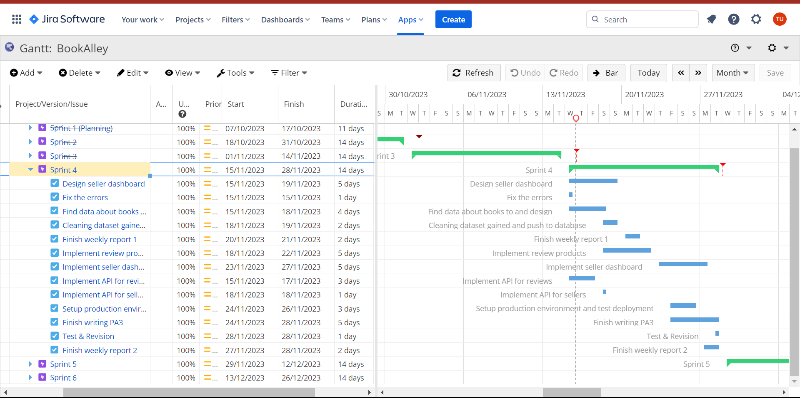

* Sprint 5:

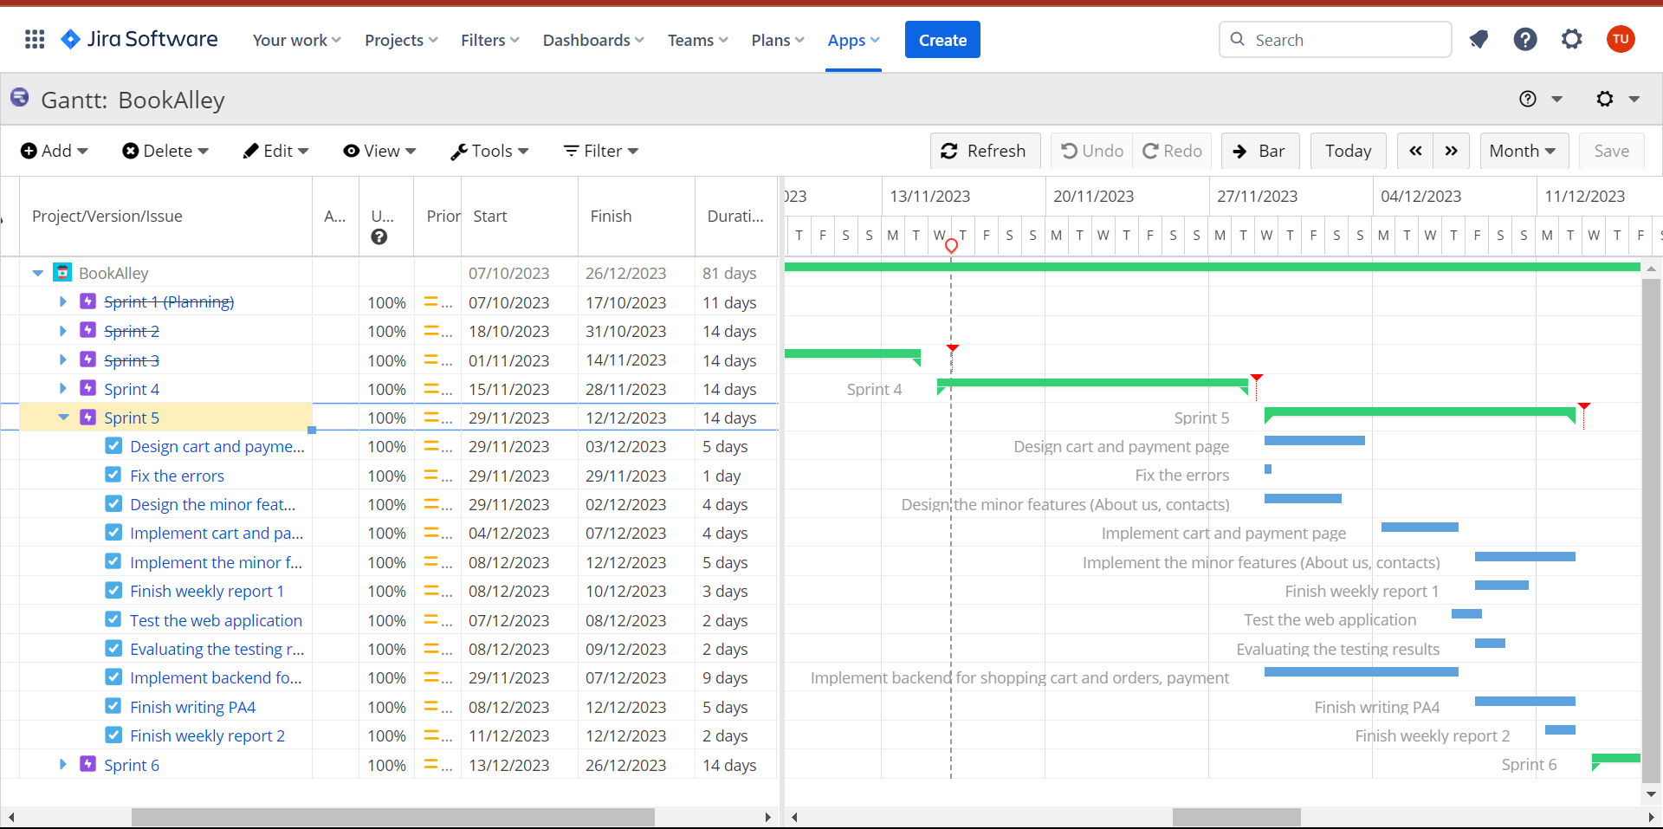

* Sprint 6:

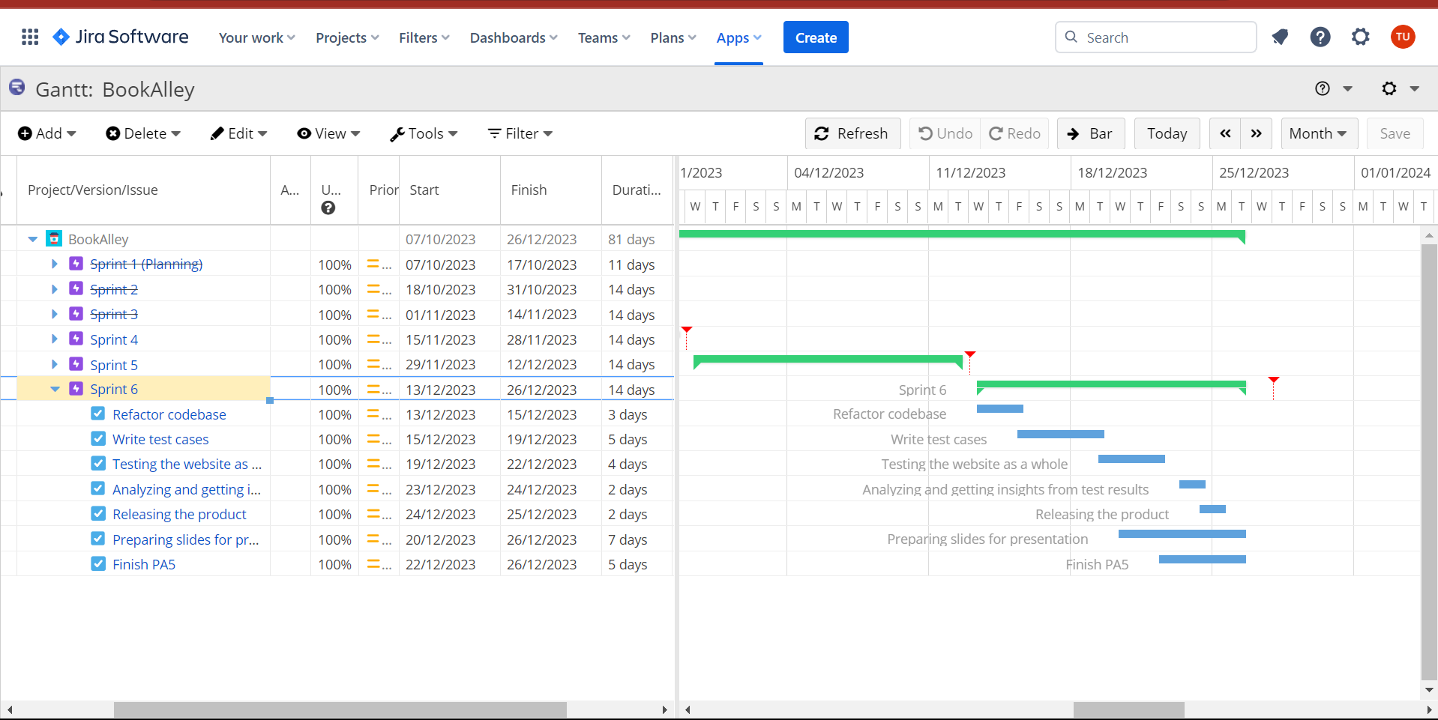

### Project Resourcing

This project is done by a 5-person group:

| **Member** | **Special skills** | |
| --- | --- | --- |
| Nguyễn Minh Khôi | Managing project, Front-end developing | |
| Trần Minh Hải Uyên | Designing, testing product | |
| Phùng Siêu Đạt | Back-end developing and cyber security | |
| Đặng Hà Huy | Designing, document writing, | |
| Châu Tấn Kiệt | Data handling, database managing | |

## Project Monitoring and Control

### Requirements Management

The requirements for this system are captured in the Vision document. Requested changes to requirements are captured in Change Requests, and are approved as part of the Configuration Management process.

### Reporting and Measurement

* Weekly reports are located on Google Drive
* Jira is the place to assign tasks to each member
* Discord, Messenger and Slack are where the member discuss as well as make important announcement regarding the project

### Risk Management

Risks will be identified in Inception Phase using the steps identified in the RUP for Small Projects activity “Identify and Assess Risks”. Project risk is evaluated at least once per iteration and documented in this table. The risks of the greatest magnitude are listed first in the table.

| **Risk Ranking (High, Medium, Low)** | **Risk Description and Impact** | **Mitigation Strategy and/or Contingency Plan** |
| --- | --- | --- |
| Medium | Description: Lack of communication  Impact: Misalignment, conflict, quality issues and delayed process | - Develop a communication plan that outlines how, when, and what information will be communicated throughout the project  - Schedule regular team meetings to discuss project progress, challenges, and goals  - Establish a process for resolving conflicts and misunderstandings in a constructive and timely manner. |
| High | Description: Data security leakage  Impact: Information disclosure, data exposure | - Use strong encryption methods to protect data, making it challenging for unauthorized users to access sensitive information.  - Continuously monitor and audit system logs and data access to detect and respond to suspicious activities promptly.  - Regularly backup data to ensure that it can be restored in the event of data loss or corruption. |
| High | Description: Software bugs  Impact: Infrastructure damages, data corruption and loss, increased maintenance costs and project delays | - Conduct thorough code reviews to identify and fix bugs at an early stage.  - Establish a bug tracking system to record, prioritize, and manage reported bugs  - Use version control systems to track code changes and maintain a history of the software's development  - Always have backup and rollback plans in place to recover from severe software issues and minimize data loss. |
| Medium | Description: Low performance of members  Impact: Project delays, reduced productivity, team conflict | - Set clear, specific, and achievable performance expectations for team members. Ensure that everyone understands their roles and responsibilities.  - Identify skill gaps and provide training and development opportunities to help team members improve their performance.  - Pair low-performing team members with experienced colleagues who can mentor and provide guidance.  - Hold team members accountable for their performance and adherence to project deadlines and goals. |

### Configuration Management

* Google Drive: store all the important documents as well as weekly report and sprint meeting/planning
* Jira: Assign task for member and evaluate result after each sprint
* Github: Store source code of the project
* Figma: Where all member come up with the idea and design for the website